Spatial Variation in Trophic Structure of Nearshore Fishes in Lake Michigan as it Relates to Water Clarity

Benjamin A. Turschak*^{1, 2}, Sergiusz Czesny³, Jason C. Doll⁴, Brice K. Grunert⁵, Tomas O. Höök ⁶, John Janssen¹, and Harvey A. Bootsma¹

*Corresponding Author: turschakb1@michigan.gov
¹School of Freshwater Sciences, University of Wisconsin-Milwaukee, 600 East Greenfield Avenue, Milwaukee, Wisconsin 53204 (BAT: turschak@uwm.edu; JJ: jjanssen@uwm.edu; HAB: hbootsma@uwm.edu)
²Charlevoix Fisheries Research Station, Michigan Department of Natural Resources, 96 Grant Street, Charlevoix, Michigan 49720 (BAT: turschakb1@michigan.gov)
³University of Illinois, Illinois Natural History Survey, Lake Michigan Biological Station, 400 17th Street, Zion, Illinois 60099 (SC: czesny@illinois.edu)
⁴Quantitative Fisheries Center, Department of Fisheries and Wildlife, Michigan State University, 375 Wilson Road., 101 UPLA Building, East Lansing, MI 48824 (JCD: dolljas1@msu.edu)
⁵Department of Geological and Mining Engineering and Sciences, Michigan Technological University, 1400 Townshend Drive, Houghton, Michigan 49931-1295 (BKG: bgrunert@mtu.edu)
⁶Purdue University, Department of Forestry and Natural Resources, 195 Marsteller Street, West Lafayette, Indiana, 47907-2033 (TOH: thook@purdue.edu)

Abstract:
Nearshore water clarity, as measured by remotely sensed K_{d}(490), and stable C and N isotopes of several nearshore fishes differed across the Lake Michigan basin. δ¹³C of Round Goby, Yellow Perch, and Spottail Shiner were depleted in the southeast where water clarity was low relative to the southwest where water clarity was greater. Bayesian analyses were used to evaluate spatial variation in diet composition and quantify the relationship between water clarity and the proportional importance of pelagic energy in fish diets. Water clarity in nearshore areas is likely related to variable riverine inputs, resuspension, and upwelling processes. While these processes may not directly impact δ¹³C or δ¹⁵N of nearshore fishes, we hypothesize that water clarity differentially affects benthic and pelagic algal production. Lower water clarity in the benthos and subsequently lower benthic productivity may be related to regional diet differences and increased reliance on pelagic energy sources. Mobile fishes such as Alewife may not be in isotopic equilibrium with regional prey sources and depart from spatial patterns observed in other nearshore fishes.

Key Words:
Remote sensing, stable isotopes, water clarity, trophic relationships

Introduction:
Ecologists recognize that ecosystem processes (e.g. primary production, nutrient cycling, energy flow) change along environmental gradients over broad spatial scales (Vannote et al. 1980; Turner 1989; Polis et al. 1997; Allan 2004). With technological advances in Geographic Information Systems (GIS) and remote sensing techniques, it has become easier to assess how large scale patterns in ecosystem structure and function are related to terrestrial and aquatic physiography (Turner 1989; Levin 1992; West et al. 2010). However, it remains difficult to assess dynamic ecosystem processes such as energy flow and nutrient cycling over broad spatial scales, and how these processes are affected by physical and geochemical gradients, particularly when the process of interest is variable over short time scales (Turner 1989).
Large lakes and their surrounding catchments often cover broad geographic regions with diverse land-use, geology, and drainage regimes (Robertson 1997). Lake Michigan, the second largest Laurentian Great Lake (58,030 km²), is influenced strongly by wind driven physical processes and internal chemical cycling. The lake’s nearshore environment is highly variable, due to spatial differences in bathymetry, shoreline structure, bottom type, and riverine inputs (Boyce 1974, Eadie et al. 1984; Conley et al. 1988; Janssen et al. 2005). As a result, there is a range of environmental gradients much larger than observed in most small lakes. As such, it is to be expected that food web structure and energy flow pathways will also vary both spatially and temporally.
Several studies of nearshore fishes in Lake Michigan have investigated spatial heterogeneity in diets using multiple indicators including fatty acids, gut content analysis, and stable isotopes (Happel et al. 2015a; 2015b; Foley et al. 2017). These studies suggest that spatial variation in physical conditions such as fluvial input and substrate type as well as regional differences in primary production pathways may result in regional diet differences (Happel et al. 2015a; 2015b; Foley et al. 2017). Despite apparent spatial variation in nearshore fish diets and energy pathways, it remains unclear how this variation may be related to broader scale physical or geochemical gradients.
While stable C and N isotope ratios are extremely useful for determining energy flow pathways within aquatic food webs (Hecky and Hesslein 1995; Vadeboncoeur et al. 2002), they can also be used to gain insight into biogeochemical processes, including nutrient loading, nutrient cycling, and carbon fixation (Hama et al. 1983; Ostrom et al. 1997; Kumar et al. 2011), which in turn reflect physical properties and processes such as land use, water clarity, river discharge, and substrate type. Therefore, a detailed analysis of stable C and N isotope ratios (expressed as δ¹³C and δ¹⁵N, respectively) can provide insight into the relationships between physical environmental gradients and food web structure over broad spatial scales (West et al. 2010). Stable isotope ratios vary as a result of isotopic fractionation, a process by which the isotope ratios of reactants and products diverge during chemical reactions (Peterson and Fry 1987). For aquatic organisms, δ¹³C can be used to trace the relative contribution of isotopically heavy benthic primary producers and isotopically light pelagic primary producers to higher trophic levels (France 1995; Hecky and Hesslein 1995; Bootsma et al. 1996). δ¹⁵N increases in a stepwise fashion with each trophic transfer which makes it a useful measure of consumer trophic level (DeNiro and Epstein 1981; Vander Zanden and Rasmussen 1999). Because isotopic fractionation is a mechanistic process, spatial patterns in stable isotopic composition of material (e.g. nutrient or detritus) or organisms can be used to infer spatial differences in ecosystem processes such as nutrient cycling and energy flow (Bowen et al. 2010), especially when spatial variation in stable isotope ratios are measured against a temporally integrated trophic baseline (Vander Zanden and Rasmussen 1999; Post 2002).
Independent spatial metrics that can be measured remotely, such as temperature, chlorophyll a, and turbidity, can be combined with stable isotope data to provide a powerful means of detecting and explaining large scale gradients in ecosystem processes (Radabaugh et al. 2013). Turbidity, which can be inferred from the diffuse light attenuation coefficient at 490 nm [K_{d}(490)] (Yousef et al. 2016), is particularly useful in that it reflects several key properties and processes that can influence nearshore energy flow, including the distribution of river plumes, sediment resuspension, and the relative availability of light to planktonic versus benthic algae (Vadeboncoeur et al. 2003; Rao and Schwab 2007; Lohrenz et al. 2008a). The distinction between planktonic and benthic production has become especially important in Lake Michigan, where the former has decreased in the past few decades (Fahnenstiel et al. 2010) while the latter has increased (Auer et al. 2010; Brooks et al. 2014), with apparent effects on much of the food web (Turschak et al. 2014).
In this study, we examine spatial patterns in stable C and N isotopes of several common fishes across 8 study sites throughout Lake Michigan’s nearshore zone. Fish species included two native species (yellow perch Perca flavescens and spottail shiner Notropis hudsonis) and two non-native species (round goby Neogobius melanstomus and alewife Alosa pseudoharengus) with variable life histories and feeding ecologies. We hypothesized that the relative importance of pelagic versus benthic energy pathways and diets among nearshore fishes in Lake Michigan reflect broad spatial variation in water clarity. Furthermore, we hypothesized that spatial patterns in the relative importance of pelagic vs benthic energy pathways among species would vary according to their life-history and feeding ecologies. Diet compositions of each species across study sites was inferred using stable isotope analysis. In addition, spatial isotopic differences were compared with spatial patterns of water clarity [K_{d}(490)] as derived from satellite imagery. This approach allowed us to determine the degree to which spatial variation in primary production pathway (i.e. benthic vs. pelagic) and nearshore trophic structure are related to spatial patterns of water clarity in this large lake.

Methods:

Sample Collection
Biological samples were collected from 8 study sites located in the nearshore zone of Lake Michigan, 2-15 m depth (Fig. 1). These sites varied widely with respect to surrounding land use, substrate type, and hydrodynamics. Most sites were sampled on three occasions (May, July, September) in 2010 and 2011 with supplemental collection occurring intermittently among sites and years.
Collection methods are the same as described by Foley et al. (2017) and Happel et al. (2015 a; 2015 b). Briefly, fish and invertebrates were collected using a variety of techniques depending on the target taxa and substrate being sampled. Fish were collected with micromesh (6 and 8 mm bar) and larger experimental gillnet sets (12.7, 19.1, and 25.5 mm bar) set at 2-5 m, 8-10 m, and 15-16 m depths. In rocky nearshore areas, benthic invertebrates were collected by scuba divers performing benthic scrapes (400 cm²) on large rocks. Over soft sediments, benthic invertebrates were collected using a Ponar grab. In the case of both benthic scrapes and Ponar grabs, triplicate samples were collected for each sample date and location. Zooplankton were collected by performing triplicate vertical daytime tows with 64 μm zooplankton net at each date and location.

Sample Processing
Fish and invertebrate samples were placed on ice in the field and then sorted immediately upon arrival in the laboratory. After sorting, samples were frozen at -28ºC until processing could be completed. Guts were removed from all fish samples. Fish <250 mm were homogenized whole after the gut was removed whereas fish >250 mm had a dorsal muscle tissue plug removed and homogenized. Paired comparison of whole-body tissue homogenate and dorsal muscle tissue plug stable isotopes have revealed little difference and so we felt justified in treating these data similarly (Turschak 2013). Benthic invertebrates were sorted by taxon into pooled samples from each site, date, and replicate, and then analyzed whole. Bulk zooplankton samples were also pooled from each site, date, and replicate, and then analyzed. Soft tissue was dissected from shell material of dreissenid mussels. Fish and invertebrate samples were then lyophilized and 3-4 mg of the dried homogenate packed into tin capsules for stable C and N isotope analysis.
Stable isotope measurements were made using the methods described in Turschak and Bootsma (2015), and Ngochera and Bootsma (2011). Briefly, isotope concentrations were measured using an isotope ratio mass spectrometer (Finnigan MAT delta S SIR-MS) with elemental analyzer front end and ConFlo II interface. Carbon calibration was done with NIST standard RM 8542 (sucrose, δ¹³C=−10.47) and a NIST-traceable standard (glycine, δ¹³C=−33.63). Nitrogen calibration was with NIST standard RM 8547 (IAEA-N1 ammonium sulfate, δ¹5N=0.4), NIST standard RM 8548 (IAEA-N₂ ammonium sulfate, δ¹⁵N=20.3), and a NIST-traceable ammonium chloride standard (δ¹⁵N=−8.9). During sample runs, an acetanilide control sample was run every twelfth sample and analyzed for ¹³C:¹²C and ¹⁵N:¹⁴N ratios. Instrument precision was ±0.2‰ for both C and N isotopes based upon acetanilide controls. All stable isotope results are expressed in δ notation (i.e. δ¹³C and δ¹⁵N) as per mil (‰) differences between the isotope ratio of the sample and that of the international standard (PDB carbonate and atmospheric air for δ¹³C and δ¹⁵N, respectively). Taxa specific lipid-corrections were applied to δ¹³C values following the equations described in Turschak and Bootsma (2015) to reduce variability associated with consumer tissue lipid content.

Data Analysis
MODIS satellite images of Lake Michigan were collected for 2010 and 2011 and then loaded into R (version 3.2.3, R Foundation for Statistical Computing) with the “ncdf4” software package. Using this software, we extracted the georeferenced level 2 K_{d}(490) data for each image, which represents the diffuse attenuation of downwelling light at a wavelength of 490 nm following a fourth-order polynomial fit of 488 nm (blue) and 555 nm (green) remotely-sensed reflectance in NASA’s NOMAD dataset (Werdell and Bailey 2005). While this algorithm is based on primarily open ocean type (Case 1) waters where optical constituents are assumed to be co-varying, it has been shown to be valid for determination of in situ K_{d}(490) in the Great Lakes, particularly Lake Michigan (Yousef et al. 2016). For Lake Michigan, we used this product as a surrogate measure of turbidity in the water column with the assumption that trends observed are primarily due to changes in the optical properties of the water column. While this study was not designed to validate satellite observations or recommend a new approach for analyzing remote imagery, we did consider the distribution of remote sensing reflectance (R_{rs}) spectra in Lake Michigan available on NASA’s SeaBASS data archive relative to the NASA bio-Optical Marine Algorithm Data set (NOMAD) used to derive the coefficients used in the algorithm retrieving K_{d}(490) from MODIS Aqua data to ensure we were operating within a similar optical space. Excluding observations in highly eutrophic areas not considered here (e.g. southern Green Bay), Lake Michigan R_{rs} spectra fell predominantly around the median NOMAD R_{rs} values, and between the 25% and 75% quantiles of the NOMAD dataset (Supplementary material Appendix 1 Fig. A1). Lake Michigan stations fell well within the distribution of the NOMAD dataset without a statistically significant bias towards any region of the NOMAD dataset. From this, we assumed we were operating within a similar optical space and proceeded to use satellite-derived K_{d}(490) as an indicator of water column light availability over the study period.
MODIS image data were matched to study site locations with a Euclidean nearest neighbor approximation. The nine 1 km² image pixels (3 x 3 grid) centered around each study site were found and then averaged to produce a daily K_{d}(490) value for all eight study sites in each image (Bailey and Werdell 2006). Although one image per day was captured for Lake Michigan, cloud cover over study locations resulted in missing data for certain sites on certain dates. The median and median absolute deviation (mad) of all cloud free images for each study site from 2010 and 2011 were calculated. Median and median absolute deviation were used to characterize central tendency and variance instead of mean and standard deviation because K_{d}(490) data were not normally distributed; these metrics give less weight to extreme values that are typically anomalous and inaccurate in remotely sensed data sets.
Because study sites were in nearshore regions, some pixel values had to be excluded due to proximity to shore, resulting in less than 9 pixels, with an average of 4.3 pixels for all applied values. There is potential for bottom effects (e.g. light reflected from bottom substrate) in retrieved pixels; however, we were not able to determine the degree to which satellite derived measurements were influenced by bottom reflectance. For the sake of simplicity, we assume that bottom effects were negligible. Potential errors in data interpretation due to this assumption are discussed below. For graphical representation, only (e.g. Fig. 1), images with <90% cloud cover were interpolated to a fixed grid (0.01º x 0.01º grid cells) over Lake Michigan using an inverse distance weighted interpolation algorithm (Figure 1).
We quantified the diets of nearshore fishes across sites using a Bayesian mixing model approach. The “MixSIAR” package (Stock and Semmens 2013) built for R was used to quantify dietary proportions of prey sources using δ¹³C and δ¹⁵N as tracers, region as a random effect factor, and total length as a covariate. Potential prey sources for each species were the same as those used in Turschak and Bootsma (2015) but isotope ratios of prey were site-specific. In addition to source isotope data, trophic enrichment factors (mean ± sd) of 0.4 ± 1.3 for δ¹³C and 3.4 ± 1.0 for δ¹⁵N were provided as model inputs (Post 2002). We used default vague prior probability distributions with three Markov chain Monte Carlo (MCMC) simulations of 1,000,000 iterations. The burn-in period for each iteration chain was set at 500,000 and the subsequent values were thinned by a factor of 500. Chain convergence was checked using the Gelman-Rubin and Geweke diagnostic tests. If chains had not converged, a second model run was performed with three chains of length 3,000,000, burn-in period of 1,500,000, and thinned by a factor of 500.
We additionally attempted to quantify the relationship between dietary proportions from benthic and pelagic sources with water clarity (as measured by daily K_{d}(490)) at each sample location and total length of individual fish. To prepare the data for these calculations, a correction factor was first applied to the δ¹³C values of fish to account for trophic enrichment such that $δ^{13}C_{TEF}=δ^{13}C_{fish}-∆$, where Δ is described by the following equation (Ives et al. 2013):
$∆={TEF}_{C}\left[\frac{\left(δ^{15}N_{fish}-δ^{15}N_{pc}\right)}{{TEF}_{N}}\right]$.
Trophic enrichment factors represent the average per mil shift in δ¹³C and δ¹⁵N (TEF_{C} = 0.4‰ and TEF_{N} = 3.4‰, respectively) resulting from fractionation that occurs from one trophic level to the next (Post 2002). δ¹⁵N_{pc} is the overall baseline δ¹⁵N calculated as the mean δ¹⁵N of both benthic and pelagic primary consumers (i.e. amphipods, isopods, chironomids, oligochaetes, and dreissenid mussels). The pelagic source and benthic source model inputs were dreissenid mussels and non-dressienid benthic invertebrates (amphipods, isopods, chironomids and oligochaetes), respectively. Although not all fish consume these source groups directly, relatively long-lived primary consumers (e.g. mussels) serve as time-integrated representatives of basal pelagic and benthic δ¹³C sources (Cabana and Rasmussen 1996; Vander Zanden and Rasmussen 1999; Post et al. 2000). Because not all benthic taxa were present at all sites, the benthic source was calculated using an unweighted combined average δ¹³C of all amphipod, isopods, chironomids and oligochaetes and the pelagic source was calculated using the average δ¹³C of nearshore (<15 m depth) dreissenid mussels.
With consumer δ¹³C values adjusted for trophic enrichment and benthic and pelagic sources established, we then extended the Bayesian mixing model of the “MixSIAR” package to incorporate a hierarchical region-specific intercept that is a function of water clarity with the additive covariate of individual fish total length. Thus, we characterize dietary proportions at two levels (i.e., split-plot design). The first level describes variation in dietary proportion across total length.
$$f\left(y\right)\sim Normal\left(β_{0x}+β_{1}*{TL}_{i}\right)$$
Where f(y) is the centered log ratio (CLR) transformation of the relative contributions of each energy source (benthic or pelagic) and using δ¹³C as a single tracer. Here, the benthic source was calculated using the regional average δ¹³C of all amphipod, isopods, chironomids and oligochaetes and the pelagic source was calculated using the regional average δ¹³C of nearshore (<15 m depth) dreissenid mussels. $β_{0x}$ is the region-specific intercept, $β_{1}$ is the coefficient of total length, and TL_{i} is the total length of individual i. The second level of the model describes variation in dietary proportion across regions as a function of K_{d}(490).
$$β_{0x}\sim Normal\left(β_{2}+β_{3}*μ_{x},σ\right)$$
Where $β_{2}$ is the intercept describing the global mean composition in CLR space, $β_{3}$ describes the effects of mean K_{d}(490) value on the overall mean composition, $μ_{x}$ is the mean K_{d}(490)value at region x, and $σ$ is the standard deviation of the region specific intercept. An additional consideration is daily measurements of K_{d}(490) in each region and its associated uncertainty. To account for variation in K_{d}(490), we integrated a second model to describe the K_{d}(490) values at each site. Estimation of the mean K_{d}(490) value ($μ_{x}$) and its uncertainty at each region was accomplished by incorporating the individual K_{d}(490) values at each region into the model.
$${Kd}_{xi}\sim Lognormal\left(μ_{x},τ_{x}\right)$$
Where Kd_{xi} are the observed daily K_{d}(490) values in region x, and $τ_{x}$ is the standard deviation of K_{d}(490) values at region x on a log scale. Thus, parameter estimates represent the joint posterior probability distribution that incorporate individual variation in dietary composition with the effect of total length and region effects that are a function of K_{d}(490) values.
We used default vague prior probability distributions in MixSIAR (Stock and Semmens 2013) for the region random effects model. Additional parameters for the K_{d}(490) were also given vague prior probability distributions ($β_{2}$ was given a vague Dirichlet prior on the transformed composition; $β_{3}$ and $μ_{x}$ were given independent normal distributions with mean = 0 and precision = 0.001; and $σ$ and $τ_{x}$ were given independent gamma distributions with shape and rate = 0.001 with three MCMC simulations of 2,505,000 total iterations. The burn-in period for each iteration chain was set at 5,000 and the subsequent values were thinned by a factor of 50 for a total of 50,000 saved iterations. Chain convergence was checked using the Gelman-Rubin and Geweke diagnostic tests.

Results:
Median light extinction coefficients as measured by K_{d}(490) varied across study sites in 2010 and 2011 (Median = 0.14 - 0.61 m⁻¹; Table 1; Fig. 1) with the lowest values in the southwestern basin (sites 2 and 3) and highest in the southeastern basin (sites 6 and 7). Furthermore, variation in K_{d}(490) differed among study sites (MAD = 0.04-0.73 m⁻¹) with lower variation observed at the southwestern study sites (sites 2 and 3) than at the southeastern study sites (sites 6 and 7; Table 1; Fig. 1). Greater K_{d}(490) median and MAD observed in the southeastern study sites particularly during the spring and summer of 2010 and 2011 (Table 1).
Regional patterns were also observed in the δ¹³C and δ¹⁵N of nearshore fishes (Fig. 2 a-h). In particular, round goby (Fig. 2a), yellow perch (Fig. 2c) and spottail shiner (Fig. 2e) δ¹³C exhibited spatial differences which were nearly directly inverse to that of K_{d}(490) with relatively high values in the southwestern basin and lower values in the southeastern basin. Differences in mean δ¹³C among study sites differed by as much as 5.38‰, 2.66‰, and 3.97‰ for round goby, yellow perch, and spottail shiners, respectively, between southwest and southeast study sites (Fig 2a, 2c and 2e). Only alewife diverged from this spatial pattern with relatively uniform δ¹³C or <1.41‰ mean differences among all sites (Fig 2g). By comparison, the δ¹⁵N of most nearshore species did not vary as much as δ¹³C nor did it vary in a spatially consistent manner across our study sites (Fig. 2b, 2d, and 2f). Round goby (Fig. 2b), yellow perch (Fig. 2d), and spottail shiner (Fig. 2f) mean δ¹⁵N varied by less than 1.32‰ among study sites. Interestingly, only alewife exhibited larger regional variation (3.90‰) in δ¹⁵N which was driven by the depleted δ¹⁵N at site 1 (Sturgeon Bay) compared to the other sites (Fig. 2h). δ¹⁵N values this low were not observed in any other fish species sampled in this study.
Bayesian mixing model results indicated both regional and ontogenetic differences in the diets of nearshore fishes (Fig. 3-6). Round goby relied more on benthic invertebrates at western and northern study sites, 1-4 and 8, relative to south eastern study sites, 5-7, where dreisenid mussels were a more important diet item (Fig. 3). For example, round goby posterior diet proportions of benthic invertebrates were 0.361 (95% CI = 0.282 to 0.447) greater at site 2 (Milwaukee) in the southwest than at site 6 (Saugatuck) in the southeast. Furthermore, there was a strong ontogenetic shift to greater reliance on nearshore dreissenid mussels with increasing total length across all study sites (Fig. 3). The proportion of alewife prey in yellow perch posterior diet estimates were more than 0.28 (95% CI = -0.02 to 0.60) greater at site 7 (Muskegon) than at all other study sites (Fig. 4). Similar ontogenetic patterns were observed for yellow perch across study sites with a high degree of zooplanktivory at small sizes then transitioning to benthic invertebrates and fish prey at intermediate and larger sizes, respectively (Fig. 4). The proportion of benthic invertebrate prey in spottail shiner posterior diet estimates were more than 0.28 (95% CI = -0.226 to 0.570) greater at site 2 (Milwaukee) than at all other study sites (Fig. 4) but there were no strong or consistent ontogenetic shifts among study sites (Fig. 5). Alewife appear to have similar diets across study sites except for site 1 and 2 (Sturgeon Bay and Milwaukee) where posterior diet proportions of offshore cladocerans are more than 0.38 (95% CI = 0.145 to 0.702) and 0.15 (95% CI = -0.515 to 0.773) greater than at all other study sites (Fig. 6), respectively. Among study sites, alewives were relatively more reliant on nearshore zooplankton at small sizes then transitioned to offshore cladocerans and offshore copepod prey at intermediate and larger sizes, respectively (Fig 6).
The proportion of pelagic energy (α) assimilated by nearshore fishes increased as a function of both increasing total length and increasing K_{d}(490) among all nearshore fishes (Fig 7). For example, posterior predictions of round goby α increased by 0.215 (95% CI = 0.09 to 0.38) across a range of sizes from 25 mm to 125 mm while fixing K_{d}(490) at 0.15 m⁻¹. Likewise, at a fixed total length of 75 mm, round goby α increased by 0.728 (95% CI = 0.337 to 0.895) over a range of K_{d}(490) values from 0.15-0.75 m⁻¹ (Fig. 7 b). Yellow perch and spottail shiner exhibited similar changes in α resulting from increasing K_{d}(490) however the effect of total length on α was relatively smaller in these species. α increased by 0.355 (95% CI = 0.134 to 0.539 ; Fig. 7 d-f) for yellow perch (150 mm) and by 0.481 (95% CI = 0.199 to 0.703; Fig. 7 g-i)) for spottail shiners (100 mm) over a range of K_{d}(490) values (0.15-0.75 m⁻¹). Posterior predictions for small alewife (50 mm) α increased greatly by 0.960 (95% CI = 0.362 to 1.00) over a range K_{d}(490) values (0.15-0.75 m⁻¹, Fig. 7 j)). However, at larger sizes (e.g. 150mm) alewife α varied little over a range of K_{d}(490) and remained very near 1 (Fig 7 k-l).

Discussion:
To our knowledge, this is the first paper to use satellite observations to explain spatial patterns in the food web structure and diets of nearshore fishes in a large lake. Results indicate that this approach can offer valuable insight into explaining spatial variability in isotopic composition and trophic structure. By combining remotely-sensed K_{d}(490) with traditional methods of stable isotope ecology, we were able to quantify the relationship between water clarity and trophic structure for fishes with variable life history strategies. In particular, the proportion of pelagic energy (α) of several species of nearshore fishes in Lake Michigan varied strongly as a function of K_{d}(490) and moderately as a function total length. Furthermore, the specific diet components of Lake Michigan fishes also varied regionally and may be related to water clarity as measured by K_{d}(490).
K_{d}(490) was greatest in the southeastern portion of Lake Michigan and lowest in the southwestern portion of the basin, consistent with recent trends in remotely-sensed estimates of Secchi depth and suspended minerals (Shuchman et al. 2006; Binding et al. 2015). The spatial differences in K_{d}(490) are likely the result of variation in fluvial inputs, frequency of resuspension events, upwelling events and/or differences in phytoplankton abundance. Several major rivers including the St. Joseph River, Kalamazoo River, Grand River, and Muskegon River terminate in the southeastern portion of Lake Michigan between sites 5 and 7 draining a large catchment area of agricultural and urban land use (Robertson 1997). By contrast, the catchment along the southwestern portion of Lake Michigan includes several moderate to small rivers which drain relatively smaller agricultural and urban catchment areas (Robertson 1997). Therefore, it is probable that sediment being carried from rivers in the southeastern basin increase the nearshore mean annual turbidity between sites 5 and 7 relative to the southwest region where the watershed is smaller (Lohrenz et al. 2004). Likewise, frequent sediment resuspension events in southeast Lake Michigan likely contribute to the higher apparent turbidity in this region (Eadie et al. 1984; 2002, Mortimer 1988; Schwab et al. 2006). These resuspension events can be very large; one major event can resuspend as much fine sediment as total annual inputs to the entire lake basin (Eadie et al. 1990; 2002). By contrast, upwelling events are more common on the western shore of Lake Michigan, due to prevailing westerly winds (Boyce 1974; Plattner et al. 2006). These upwelling events typically carry clear, nutrient rich hypolimnetic water to the surface, which may stimulate increased primary production (Haffner et al. 1984; Dunstall et al. 1990; Lesht et al. 2002). A combination of major fluvial input, resuspension and upwelling may be occurring simultaneously given their episodic nature which makes disentangling their effects difficult . In general, however, higher median and MAD K_{d}(490) in the southeast basin, particularly during the spring and summer, suggest more frequent episodic turbidity events in this region relative to the southwestern basin (Table 1).
River plumes can decrease local water clarity and may offer one possible explanation for the apparent linkage between K_{d}(490) the enriched δ¹³C of round goby, yellow perch and spottail shiners in southwestern Lake Michigan relative to the southeast (Lohrenz et al. 2004). Fluvial seston inputs, particularly in the southeastern basin, are ¹³C depleted relative to Lake Michigan seston (Larson et al. 2012; Marko et al. 2013). Therefore, if large quantities of fluvial particulate organic carbon are entering the nearshore food web in the southeastern region, it would be reasonable to expect lower δ¹³C compared to the southwest where fluvial carbon input is likely much lower. Although large spatial variation in δ¹³C was apparent, we observed little spatial variability in δ¹⁵N of round goby, yellow perch and spottail shiners among study sites. Larson et al. (2012) also observed low variability in the δ¹⁵N of Lake Michigan nearshore consumers near river mouths, in contrast to relatively high δ¹⁵N variability for river seston and biota. Similarly, Peterson et al. (2007) concluded that the isotopic composition of biota in open nearshore habitats near tributary mouths is influenced minimally by tributary inputs. Given the relatively small range of δ¹⁵N values we observed in nearshore fishes, it seems unlikely that fluvial seston is making a significant direct contribution to the nearshore food web though indirect effects on productivity may be an important factor (Lohrenz et al. 2004; 2008a; Kerfoot et al. 2010).
Alternatively, we suggest that spatial variation in nearshore fish δ¹³C is likely related to regional water clarity and its effects on benthic versus pelagic energy pathways. K_{d}(490) values are directly related to water clarity and to the attenuation of photosynthetically available radiation (PAR) (Pierson et al. 2008). Though reduced water clarity affects both benthic and pelagic primary producers, the effects are proportionately greater on the former (McCauley et al. 1989, Vadeboncoeur et al. 2003). We made regional estimates of K_{d}(PAR) following a relationship for the Baltic Sea—a coastal (Case 2) system (Pierson et al. 2008). Using 2010-2011 median K_{d}(490) extinction coefficients for our lowest light attenuation site (site 3; 0.14) and highest light attenuation site (site 6; 0.61) as input, produced K_{d}(PAR) values of 0.18 and 0.48, respectively. These K_{d}(PAR) values suggest a typical photic depth (Zeu=4.6/K_{d}(PAR)) of 25.6 and 9.6m, respectively (Kirk 1994). Considering these typical conditions and a fixed depth of 10 m (i.e. the mid-point for most of our nearshore sampling), site 3 consistently has light available to the benthos while site 6 generally does not receive appreciable light in the benthic layer. Other studies have empirically corroborated these estimates and have shown increased benthic algal production in southwestern Lake Michigan particularly near sites 2 and 3 and a paucity of benthic algal production near southeast study sites 5-7 (Auer et al. 2010; Brooks et al. 2015). Because benthic primary producers tend to be more ¹³C enriched than phytoplankton (France 1995; Hecky and Hesslein 1995), generalist consumers that can take advantage of benthic energy pathways are likely to also possess heavier δ¹³C signals. In the southeastern region of Lake Michigan, light limitation likely has a proportionately larger effect on the δ¹³C of benthic algae than on phytoplankton resulting in the convergence of benthic and pelagic energy sources (Vadeboncoeur et al. 2003; Chandra et al. 2005). Conversely, the combination of both higher water clarity and rocky substrate in the southwestern region may facilitate increased benthic primary production and greater food web reliance on enriched benthic δ¹³C sources (Janssen et al. 2005; Shuchman et al. 2006; Kornis and Janssen 2011).
If benthic production is indeed lower in nearshore regions with higher K_{d}(490), then increased nearshore fish α values at higher K_{d}(490) sites suggests that primary production rates not only influence the productivity of higher trophic levels, but also the trophic structure (Melack 1976; Ware and Thomson 2005). Indeed, combining Bayesian posterior estimates of α for high clarity sites 2-4 in the southwest and low clarity sites 5-7 in the southeast and evaluating the differences reveals greater reliance on pelagic energy in the southeast for round goby, yellow perch and spottail shiner. Therefore, it seems probable that increased light attenuation or lower water clarity is related to reduced energy flow through the benthic energy pathway and greater reliance on pelagic energy pathways. Other studies have also shown that the transition from littoral periphyton production to pelagic phytoplankton production results in generalist littoral consumers becoming more dependent on pelagic energy sources in smaller lakes (Vadeboncoeur et al. 2003; Chandra et al. 2005). These patterns were observed along gradients of increasing total phosphorus and reduced water clarity corresponding to cultural eutrophication (Vadeboncoeur et al. 2003; Chandra et al. 2005). While Lake Michigan has undergone oligotrophication resulting from invasive dreissenid mussels, spatial heterogeneity in nearshore water clarity with subsequent effects on productivity processes are likely related to similar differences in regional trophic structure and energy flows.
Mixing model results estimating proportions of specific diets items generally support the finding that nearshore fishes are more dependent on pelagic energy pathways at lower water clarity sites in the southeast although site specific variation is apparent. Round gobies in particular responded to increased K_{d}(490) by shifting to greater reliance on a pelagic energy pathway. Our results indicate that this difference corresponds to increased reliance on dreissenid mussels at southeastern study sites where K_{d}(490) is greatest and is consistent with fatty acid and gut content data collected in a parallel study (Fig. 6, Foley et al. 2017). This shift may be related to decreased availability of non-dreissenid benthic invertebrates in the southeast relative to the southwest where benthic primary production is greater (Happel et al. 2015a; 2015b; Foley et al. 2017). Diet switching from soft-bodied benthic invertebrates to dreissenid mussels was also apparent for round goby and resulted in the most marked ontogenetic shift from benthic to pelagic energy pathway among the species included in this study. This result is consistent with other studies which have observed greater consumption of dreissenids by large round gobies (Turschak and Bootsma 2015; Foley et al. 2017).
By comparison, α values of yellow perch and spottail shiners also indicated greater reliance on pelagic energy pathways as K_{d}(490) increased although ontogenetic shifts in primary energetic pathway were not as strong. Mixing models for yellow perch revealed higher reliance on non-dreissenid benthic invertebrate prey at southwestern sites 2 and 3 and much lower benthic invertebrate contributions at southeastern site 7 where K_{d}(490) was higher. This diet pattern was similar to the findings of Happel et al. (2015a). Despite this, mixing model results of yellow perch from site 6 in the east were not different than western sites, perhaps in response to localized substrate (rocky) which can dominate diet patterns (Happel et al. 2015a). Ontogenetic diet shifts from invertebrates to fishes were very apparent for yellow perch and have been documented in other studies (Turschak and Bootsma 2015). Similar to yellow perch, spottail shiner mixing models revealed a strong reliance on non-dreissenid benthic invertebrates at site 2 in the southwest, comparable to the findings of Happel et al. (2015b) but generally little ontogenetic shift in diet proportions across the size range observed in this study.
Alewife α varied much more at small sizes than at larger sizes in this study. Although our results indicate a large effect of increasing K_{d}(490) on the α of small alewife , this pattern is highly variable and is likely due to the high variability among individuals and across study sites at this size. Larger alewife exhibited strong reliance on pelagic energy source across a range of K_{d}(490) values. We expect that this lower spatial variability arises from the high mobility of this species relative to other nearshore fishes which are more likely to remain in a small geographic area following the larval drift period (Ray and Corkum 2001; Beletsky et al. 2007; Glover et al. 2008). By making relatively large lateral nearshore-offshore movements, diel vertical movements, and perhaps broader regional movements, alewives effectively integrate any spatial variation in isotopic baseline. Our methodology, which assesses consumer α using a δ¹³C mixing model with regional benthic and pelagic primary consumers endmembers, is likely inappropriate for alewife because they are not in isotopic equilibrium with these regional baselines.
Increased reliance on nearshore benthic energy sources has been documented in the Lake Michigan food web as a result of declining offshore productivity and increased nearshore productivity (Hecky et al. 2004, Fahnenstiel et al. 2010, Vanderploeg et al. 2010, Turschak et al. 2014). However, it is well established that nearshore areas are highly variable in physical conditions including water clarity (Janssen et al. 2005; Lohrenz et al. 2008b; Brooks et al. 2015) and the results of this study suggest that nearshore fishes’ primary energetic pathways and diets respond to variation in these local conditions. Nearshore fishes such as the round goby can serve as conduits through which nearshore energy is transferred to higher trophic levels (Johnson et al. 2005; Dietrich et al. 2006; Foley et al. 2017). Therefore, by responding to regional differences in physical conditions and, by extension, dominant primary production pathways, nearshore fishes may be able to facilitate the transfer of energy from lower trophic levels to higher trophic levels across a broad range of nearshore conditions. This energy transfer may be very important in the midst of declining offshore productivity.
The spatial extent of this work consists of only a subset of nearshore areas in the Lake Michigan basin and is limited in coverage of nearshore areas in the northern basin and open water areas. While this is still valuable given the growing importance of nearshore areas in the Laurentian Great Lakes (Hecky et al. 2004; Turschak et al. 2014), more spatially comprehensive surveys of isotopic data are needed for the entire lake basin. These surveys could be used to create isoscapes which could then be paired with existing physical and biogeochemical data from empirical data sets, models, or remote sensing (Bowen et al. 2010; West et al. 2010). Combining isoscapes with other spatial data can provide a more mechanistic understanding of how energy and nutrients flow through the food web across a range of large scale physical gradients such as water clarity (Bowen et al. 2010). Such data will also serve as valuable baseline data for future studies addressing the impact of nutrient loading, species invasion and climate change over broad spatial scales (Radabaugh et al. 2013).

Acknowledgements:
We would like to thank Erin Wilcox, Patrick Anderson, Chris Houghton, Jeff Houghton, Austin Happel, Deborah Lichti, Sarah Creque-Thomas, Lee Henebry, and Carolyn Foley as well other technicians and graduate students responsible for collecting and analyzing samples. This work was supported by the Great Lakes Restoration Initiative GL-00E00720-0, Wisconsin Sea Grant, and Illinois-Indiana Sea Grant and is publication YYYY-NN of the Quantitative Fisheries Center at Michigan State University.

References:
Allan, J.D. 2004. Landscapes and Riverscapes : The Influence of Land Use on Stream Ecosystems. Annu. Rev. Ecol Evol Syst 35: 257–284.
Auer, M.T., Tomlinson, L.M., Higgins, S.N., Malkin, S.Y., Howell, E.T., and Bootsma, H.A. 2010. Great Lakes Cladophora in the 21st century: same algae, different ecosystem. J. Gt. Lakes Res. 36: 248–255.
Bailey, S.W., and Werdell, P.J. 2006. A multi-sensor approach for the on-orbit validation of ocean color satellite data products. Remote Sens. Environ. 102(1–2): 12–23. doi:10.1016/j.rse.2006.01.015.
Beletsky, D., Mason, D.M., Schwab, D.J., Rutherford, E.S., Janssen, J., Clapp, D.F., and Dettmers, J.M. 2007. Biophysical model of larval yellow perch advection and settlement in Lake Michigan. J. Gt. Lakes Res. 33: 842–866.
Binding, C.E., Greenberg, T.A., Watson, S.B., Rastin, S., and Gould, J. 2015. Long term water clarity changes in North America’s Great Lakes from multi-sensor satellite observations. Limnol. Oceanogr. 60(6): 1976–1995. doi:10.1002/lno.10146.
Bootsma, H.A., Hecky, R.E., Hesslein, R.H., and Turner, G.F. 1996. Food partitioning among Lake Malawi nearshore fishes as revealed by stable isotope analyses. Ecology 77: 97–101.
Bowen, G.J., West, J.B., and Dawson, T.E. 2010. Isoscapes in a Rapidly Changing and Increasingly Interconnected World. In Isoscapes. Springer Netherlands, Dordrecht. pp. 425–432. doi:10.1007/978-90-481-3354-3_20.
Boyce, F.M. 1974. Some Aspects of Great Lakes Physics of Importance to Biological and Chemical Processes. J. Fish. Res. Board Canada 31(5): 689–730. NRC Research Press Ottawa, Canada. doi:10.1139/f74-098.
Brooks, C., Grimm, A., Shuchman, R., Sayers, M., and Jessee, N. 2015. A satellite-based multi-temporal assessment of the extent of nuisance Cladophora and related submerged aquatic vegetation for the Laurentian Great Lakes. Remote Sens. Environ. 157: 58–71. doi:10.1016/j.rse.2014.04.032.
Cabana, G., and Rasmussen, J.B. 1996. Comparison of aquatic food chains using nitrogen isotopes. Ecology 93: 10844–10847.
Chandra, S., Vander Zanden, M.J., Heyvaert, A.C., Richards, B.C., Allen, B.C., and Goldman, C.R. 2005. The effects of cultural eutrophication on the coupling between pelagic primary producers and benthic consumers. Limnol. Ocean. 50(5): 1368–1376.
Conley, D.J., Quigley, M.A., and Schelske, C.L. 1988. Silica and Phosphorus Flux from Sediments: Importance of Internal Recycling in Lake Michigan. Can. J. Fish. Aquat. Sci. 45(6): 1030–1035. NRC Research Press Ottawa, Canada . doi:10.1139/f88-126.
DeNiro, M.J., and Epstein, S. 1981. Influence of diet on the distribution of nitrogen isotopes in animals. Geochim. Cosmochim. Acta 45: 341–351.
Dietrich, J.P., Morrison, B.J., and Hoyle, J.A. 2006. Alternative Ecological Pathways in the Eastern Lake Ontario Food Web--Round Goby in the Diet of Lake Trout. J. Gt. Lakes Res. 32: 395–400.
Dunstall, T.G., Carter, J.C.H., Monroe, B.P., Haymes, G.T., Weiler, R.R., and Hopkins, G.J. 1990. Influence of Upwellings, Storms, and Generating Station Operation on Water Chemistry and Plankton in the Nanticoke Region of Long Point Bay, Lake Erie. Can. J. Fish. Aquat. Sci. 47(7): 1434–1445. doi:10.1139/f90-162.
Eadie, Brian J; Vanderploeg, Henry A; Robbins, John A; Bell, G.L. 1990. Significance of sediment Resuspension and Particle settling. Large Lakes (1985): 196–223.
Eadie, B.J., Chambers, R.L., Gardner, W.S., and Bell, G.L. 1984. Sediment trap studies in Lake Michigan: resuspension and chemical fluxes in the southern basin. J. Gt. Lakes Res. 10: 307–321.
Eadie, B.J., Schwab, D.J., Johengen, T.H., Lavrentyev, P.J., Miller, G.S., Holland, R.E., Leshkevich, G.A., Lansing, M.B., Morehead, N.R., Robbins, J.A., Hawley, N., Edgington, D.N., and Van Hoof, P.L. 2002. Particle Transport, Nutrient Cycling, and Algal Community Structure Associated with a Major Winter-Spring Sediment Resuspension Event in Southern Lake Michigan. J. Great Lakes Res. 28(3): 324–337. doi:10.1016/S0380-1330(02)70588-1.
Fahnenstiel, G., Pothoven, S., Vanderploeg, H., Klarer, D., Nalepa, T., and Scavia, D. 2010. Recent changes in primary production and phytoplankton in the offshore region of southeastern Lake Michigan. J. Gt. Lakes Res. 36: 20–29.
Foley, C.J., Henebry, M.L., Happel, A., Bootsma, H.A., Czesny, S.J., Janssen, J., Jude, D.J., Rinchard, J., and Höök, T.O. 2017. Patterns of integration of invasive round goby (Neogobius melanostomus) into a nearshore freshwater food web. Food Webs 10: 26–38. Elsevier Inc. doi:10.1016/j.fooweb.2016.10.001.
France, R.L. 1995. Carbon-13 enrichment in benthic compared to planktonic algae: foodweb implications. Mar. Ecol. Prog. Ser. 124: 307–312.
Glover, D.C., Dettmers, J.M., Wahl, D.H., and Clapp, D.F. 2008. Yellow perch (Perca flavescens) stock structure in Lake Michigan: an analysis using mark–recapture data. Can. J. Fish. Aquat. Sci. 65(9): 1919–1930. doi:10.1139/F08-100.
Haffner, G.D., Yallop, M.L., Hebert, P.D.N., and Griffiths, M. 1984. Ecological Significance of Upwelling Events in Lake Ontario. J. Great Lakes Res. 10(1): 28–37. Elsevier. doi:10.1016/S0380-1330(84)71804-1.
Hama, T., Miyazaki, T., Ogawa, Y., Iwakuma, T., Takahashi, M., Otsuki, A., and Ichimura, S. 1983. Measurement of photosynthetic production of a marine phytoplankton population using a stable 13C isotope. Mar. Biol. 73(1): 31–36. Springer-Verlag. doi:10.1007/BF00396282.
Happel, A., Creque, S., Rinchard, J., Höök, T., Bootsma, H., Janssen, J., Jude, D., and Czesny, S. 2015a. Exploring yellow perch diets in Lake Michigan through stomach content, fatty acids, and stable isotope ratios. J. Great Lakes Res. 41: 172–178. International Association for Great Lakes Research. doi:10.1016/j.jglr.2015.03.025.
Happel, A., Lafountain, J., Creque, S., Rinchard, J., Höök, T., Bootsma, H., Janssen, J., Jude, D., and Czesny, S. 2015b. Spatio-temporal description of spottail shiner (Notropis hudsonius) fatty acid profiles in Lake Michigan’s southern basin. J. Great Lakes Res. 41: 179–184. International Association for Great Lakes Research. doi:10.1016/j.jglr.2015.04.013.
Hecky, R.E., and Hesslein, R.H. 1995. Contributions of benthic algae to lake food webs as revealed by stable isotope analysis. J. North Am. Benthol. Soc. 14(4): 631. doi:10.2307/1467546.
Hecky, R.E., Smith, R.E.H., Baron, D.R., Guildford, S.J., Taylor, W.D., Charlton, M.N., and Howell, T. 2004. The nearshore phosphorus shunt: a consequence of ecosystem engineering by dreissenids in the Laurentian Great Lakes. Can. J. Fish. Aquat. Sci. 61: 1285–1293.
Ives, J.T., Marty, J., de Lafontaine, Y., Johnson, T.B., Koops, M.A., and Power, M. 2013. Spatial variability in trophic offset and food sources of Hemimysis anomala in lentic and lotic ecosystems within the Great Lakes basin. J. Plankton Res. 35(4): 772–784. doi:10.1093/plankt/fbt040.
Janssen, J., Berg, M.B., and Lozano, S.J. 2005. Submerged terra incognita : Lake Michigan’s abundant but unknown rocky zones. State Lake Michigan Ecol. Heal. Manag.: 113–139.
Johnson, T.B., Bunnell, D.B., and Knight, C.T. 2005. A Potential New Energy Pathway in Central Lake Erie: the Round Goby Connection. J. Gt. Lakes Res. 31(Suppl. 2): 238–251.
Kerfoot, W.C., Yousef, F., Green, S.A., Budd, J.W., Schwab, D.J., and Vanderploeg, H.A. 2010. Approaching storm: Disappearing winter bloom in Lake Michigan. J. Great Lakes Res. 36(SUPPL. 3): 30–41. doi:10.1016/j.jglr.2010.04.010.
Kirk, J.T.O. 1994. Light and Photosynthesis in Aquatic Ecosystems, 2nd ed. Cambridge University Press.
Kornis, M.S., and Janssen, J. 2011. Linking emergent midges to alewife (Alosa pseudoharengus) preference for rocky habitat in Lake Michigan littoral zones. J. Gt. Lakes Res. 37: 561–566.
Kumar, S., Finlay, J.C., and Sterner, R.W. 2011. Isotopic composition of nitrogen in suspended particulate matter of Lake Superior: implications for nutrient cycling and organic matter transformation. Biogeochemistry 103(1–3): 1–14. doi:10.1007/s10533-010-9441-6.
Larson, J.H., Richardson, W.B., Vallazza, J.M., and Nelson, J.C. 2012. An exploratory investigation of the landscape-lake interface: Land cover controls over consumer N and C isotopic composition in Lake Michigan rivermouths. J. Great Lakes Res. 38(4): 610–619. Elsevier B.V. doi:10.1016/j.jglr.2012.09.016.
Lesht, B.M., Stroud, J., McCormick, M., Fahnenstiel, G., Stein, M., Welty, L., and Leshkevich, G. 2002. An event-driven phytoplankton bloom in southern Lake Michigan observed by satellite. Geophys. Res. Lett. 29(8): 14–18.
Levin, S.A. 1992. The problem of pattern and scale in ecology. Ecology 73(6): 1943–1967.
Lohrenz, S., Fahnenstiel, G., Schofield, O., and Millie, D. 2008a. Coastal Sediment Dynamics and River Discharge as Key Factors Influencing Coastal Ecosystem Productivity in Southeastern Lake Michigan. Oceanography 21(4): 60–69. doi:10.5670/oceanog.2008.05.
Lohrenz, S.E., Fahnenstiel, G.L., Millie, D.F., Schofield, O.M.E., Johengen, T., and Bergmann, T. 2004. Spring phytoplankton photosynthesis, growth, and primary production and relationships to a recurrent coastal sediment plume and river inputs in southeastern Lake Michigan. J. Geophys. Res. 109(C10): C10S14. doi:10.1029/2004JC002383.
Lohrenz, S.E., Fahnenstiel, G.L., Schofield, O., and Millie, D.F. 2008b. Coastal Sediment Dynamics and River Discharge as Key Factors Influencing Coastal Ecosystem Productivity in Southeastern Lake Michigan. Oceanography 21(4): 60–69. doi:10.5670/oceanog.2008.05.
Marko, K.M., Rutherford, E.S., Eadie, B.J., Johengen, T.H., and Lansing, M.B. 2013. Delivery of nutrients and seston from the Muskegon River Watershed to near shore Lake Michigan. J. Great Lakes Res. 39(4): 672–681. doi:10.1016/j.jglr.2013.08.002.
McCauley, E., Downing, J.A., and Watson, S. 1989. Sigmoid Relationships between Nutrients and Chlorophyll among Lakes. Can J. Fish. Aquat. Sci. 46: 1171–1175. doi:10.1139/f89-152.
Melack, J.M. 1976. Primary productivity and fish yields in tropical lakes. Trans. Am. Fish. Soc. 105(5): 575–580. Taylor & Francis Group . doi:10.1577/1548-8659(1976)105<575:PPAFYI>2.0.CO;2.
Mortimer, C.H. 1988. Discoveries and Testable Hypotheses Arising from Coastal Zone Color Scanner Imagery of Southern Lake-Michigan. Limnol. Oceanogr. 33(2): 203–226. doi:10.4319/lo.1988.33.2.0203.
Ngochera, M.J., and Bootsma, H.A. 2011. Temporal trends of phytoplankton and zooplankton stable isotope composition in tropical Lake Malawi. J. Gt. Lakes Res. 37: 45–53.
Ostrom, N.E., Macko, S.A., Deibel, D., and Thompson, R.J. 1997. Seasonal variation in the stable carbon and nitrogen isotope biogeochemistry of a coastal cold ocean environment. Geochim. Cosmochim. Acta 61(14): 2929–2942.
Peterson, B.J., and Fry, B. 1987. Stable isotopes in ecosystem studies. Annu. Rev. Ecol. Syst. 18: 293–320.
Peterson, G.S., Sierszen, M.E., Yurista, P.M., and Kelly, J.R. 2007. Stable Nitrogen Isotopes of Plankton and Benthos Reflect a Landscape-level Influence on Great Lakes Coastal Ecosystems. J. Great Lakes Res. 33(3): 27–41. doi:10.3394/0380-1330(2007)33[27:SNIOPA]2.0.CO;2.
Pierson, D.C., Kratzer, S., Strömbeck, N., and Håkansson, B. 2008. Relationship between the attenuation of downwelling irradiance at 490 nm with the attenuation of PAR (400 nm-700 nm) in the Baltic Sea. Remote Sens. Environ. 112(3): 668–680. doi:10.1016/j.rse.2007.06.009.
Plattner, S., Mason, D.M., Leshkevich, G.A., Schwab, D.J., and Rutherford, E.S. 2006. Classifying and Forecasting Coastal Upwellings in Lake Michigan Using Satellite Derived Temperature Images and Buoy Data. J. Great Lakes Res. 32(1): 63–76. doi:10.3394/0380-1330(2006)32[63:CAFCUI]2.0.CO;2.
Polis, G.A., Anderson, W.B., and Holt, R.D. 1997. Toward an integration of landscape and food web ecology: The dynamics of spatially subsidized food webs. Annu. Rev. Ecol. Syst. 28: 289–316.
Post, D.M. 2002. Using stable isotopes to estimate trophic position: Models, methods, and assumptions. Ecology 83(3): 703–718. doi:10.2307/3071875.
Post, D.M., Pace, M.L., and Hairston Jr., N.G. 2000. Ecosystem size determines food-chain length in lakes. Lett. to Nat. 405: 1047–1049.
Radabaugh, K.R., Hollander, D.J., and Peebles, E.B. 2013. Seasonal d13C and d15N isoscapes of fish populations along a continental shelf trophic gradient. Cont. Shelf Res. 68: 112–122. Elsevier. doi:10.1016/j.csr.2013.08.010.
Rao, Y.R., and Schwab, D.J. 2007. Transport and mixing between the coastal and offshore waters in the Great Lakes: a review. J. Gt. Lakes Res. 33: 202–218.
Ray, W.J., and Corkum, L.D. 2001. Habitat and site affinity of the round goby. J. Gt. Lakes Res. 27: 329–334.
Robertson, D.M. 1997. Regionalized Loads of Sediment and Phosphorus to Lakes Michigan and Superior—High Flow and Long-term Average. J. Great Lakes Res. 23(4): 416–439. Elsevier. doi:10.1016/S0380-1330(97)70923-7.
Schwab, D.J., Eadie, B.J., Assel, R.A., and Roebber, P.J. 2006. Climatology of large sediment resuspension events in southern Lake Michigan. J. Great Lakes Res. 32(1): 50–62. doi:Doi 10.3394/0380-1330(2006)32[50:Colsre]2.0.Co;2.
Shuchman, R., Korosov, A., Hatt, C., Pozdnyakov, D., Means, J., and Meadows, G. 2006. Verification and Application of a Bio-optical Algorithm for Lake Michigan Using SeaWiFS: a 7-year Inter-annual Analysis. J. Great Lakes Res. 32: 258–279. doi:10.3394/0380-1330(2006)32[258:VAAOAB]2.0.CO;2.
Turner, M.G. 1989. Landscape Ecology : The Effect of Pattern on Process Author ( s ): Monica Goigel Turner Source : Annual Review of Ecology and Systematics , Vol . 20 ( 1989 ), pp . 171-197 Published by : Annual Reviews Stable URL : http://www.jstor.org/stable/2097089. Ecology 20: 171–197.
Turschak, B.A. 2013. Changes in the Lake Michigan trophic structure as revealed by stable isotopes. University of Wisconsin-Milwaukee, Milwaukee, WI.
Turschak, B.A., and Bootsma, H.A. 2015. Lake Michigan trophic structure as revealed by stable C and N isotopes. J. Great Lakes Res. 41: 185–196. International Association for Great Lakes Research. doi:10.1016/j.jglr.2015.04.004.
Turschak, B.A., Bunnell, D.B., Czesny, S.J., Hook, T.O., Janssen, J., Warner, D.M., and Bootsma, H.A. 2014. Nearshore energy subsidies support Lake Michigan fishes and invertebrates following major changes in food web structure. Ecology 95: 1243–1252.
Vadeboncoeur, Y., Jeppesen, E., Vander Zanden, M.J., Schierup, H.-H., Christoffersen, K., and Lodge, D.M. 2003. From Greenland to green lakes: Cultural eutrophication and the loss of benthic pathways in lakes. Limnol. Ocean. 48(4): 1408–1418.
Vadeboncoeur, Y., Vander Zanden, M.J., and Lodge M., D. 2002. Putting the lake back together: Reintegrating benthic pathways into lake food web models. Bioscience 52(1): 44–54.
Vanderploeg, H.A., Liebig, J.R., Nalepa, T.F., Fahnenstiel, G.L., and Pothoven, S.A. 2010. Dreissena and the disappearance of the spring phytoplankton bloom in Lake Michigan. J. Gt. Lakes Res 36: 50–59. doi:10.1016/j.jglr.2010.04.005.
Vannote, R.L., Minshall, G.W., Cummins, K.W., Sedell, J.R., and Cushing, C.E. 1980. The river continuum concept. Can. J. Fish. Aquat. Sci. 37: 130–137.
Ware, D.M., and Thomson, R.E. 2005. Bottom-Up Ecosystem Trophic Dynamics Determine Fish Production in the Northeast Pacific. Science (80-. ). 308(5726).
Werdell, P.J., and Bailey, S.W. 2005. An improved in-situ bio-optical data set for ocean color algorithm development and satellite data product validation. Remote Sens. Environ. 98(1): 122–140. doi:10.1016/j.rse.2005.07.001.
West, J.B., Bowen, G.J., Dawson, T.E., and Tu, K.P. 2010. Preface. In Isoscapes: Understanding Movement, Pattern, and Process on Earth Through Isotope Mapping. doi:10.1007/978-90-481-3354-3.
Yousef, F., Shuchman, R., Sayers, M., Fahnenstiel, G., and Khalyani, A.H. 2016. Water clarity of the Upper Great Lakes: tracking changes between 1998-2012. J. Gt. Lakes Res 43(2): 239–247.
Vander Zanden, M.J., and Rasmussen, J.B. 1999. Primary consumer d13C and d15N and the trophic position of aquatic consumers. Ecology 80: 1395–1404.

Supplementary material.
Appendix 1.

Table 1
Seasonal K_{d}(490) sample size (number of cloud free images), median, and median absolute deviation (MAD) for 8 nearshore study sites (Fig 1) in 2010 (top), and 2011 (middle) as well as total K_{d}(490) sample size, median, and MAD for combined 2010 and 2011 images (bottom).
Study Site | Winter 10 |  |  | Spring 10 |  |  | Summer 10 |  |  | Fall 10
 | n | median | MAD | n | median | MAD | n | median | MAD | n | median | MAD
1. Sturgeon Bay | 38 | 0.11 | 0.04 | 35 | 0.24 | 0.24 | 46 | 0.21 | 0.20 | 34 | 0.19 | 0.11
2. Milwaukee | 24 | 0.14 | 0.04 | 24 | 0.13 | 0.06 | 44 | 0.14 | 0.05 | 37 | 0.14 | 0.03
3. Highland Park | 22 | 0.15 | 0.04 | 33 | 0.14 | 0.05 | 49 | 0.14 | 0.04 | 33 | 0.14 | 0.03
4. Calumet | 15 | 0.17 | 0.05 | 28 | 0.19 | 0.07 | 44 | 0.24 | 0.09 | 32 | 0.20 | 0.03
5. Michigan City | 12 | 0.10 | 0.04 | 37 | 0.25 | 0.18 | 53 | 0.20 | 0.16 | 33 | 0.20 | 0.03
6. Saugatuck | 23 | 0.23 | 0.21 | 33 | 2.56 | 2.95 | 46 | 1.92 | 2.42 | 32 | 0.25 | 0.16
7. Muskegon | 22 | 0.34 | 0.35 | 31 | 3.40 | 3.99 | 46 | 1.53 | 2.00 | 22 | 0.39 | 0.36
8. Sleeping Bear | 31 | 0.11 | 0.05 | 48 | 0.19 | 0.15 | 54 | 0.34 | 0.29 | 25 | 0.23 | 0.19
 | Winter 11 |  |  | Spring 11 |  |  | Summer 11 |  |  | Fall 11
 | n | median | MAD | n | mean | MAD | n | median | MAD | n | median | MAD
1. Sturgeon Bay | 34 | 0.10 | 0.03 | 34 | 1.05 | 1.40 | 52 | 1.88 | 2.53 | 33 | 0.23 | 0.14
2. Milwaukee | 22 | 0.12 | 0.04 | 23 | 0.19 | 0.09 | 41 | 0.15 | 0.06 | 33 | 0.14 | 0.05
3. Highland Park | 19 | 0.18 | 0.05 | 23 | 0.16 | 0.06 | 41 | 0.14 | 0.03 | 36 | 0.15 | 0.05
4. Calumet | 8 | 0.14 | 0.09 | 12 | 0.21 | 0.11 | 32 | 0.26 | 0.10 | 22 | 0.20 | 0.04
5. Michigan City | 14 | 0.23 | 0.05 | 17 | 0.22 | 0.07 | 42 | 0.27 | 0.13 | 27 | 0.19 | 0.06
6. Saugatuck | 23 | 0.43 | 0.35 | 24 | 1.40 | 1.43 | 47 | 1.96 | 2.56 | 29 | 0.18 | 0.06
7. Muskegon | 20 | 0.22 | 0.12 | 26 | 1.34 | 1.44 | 49 | 2.19 | 2.42 | 28 | 0.26 | 0.11
8. Sleeping Bear | 24 | 0.10 | 0.03 | 33 | 0.19 | 0.11 | 55 | 0.32 | 0.29 | 25 | 0.13 | 0.06
 | Overall
 | n | median | MAD
1. Sturgeon Bay | 306 | 0.20 | 0.17
2. Milwaukee | 248 | 0.14 | 0.05
3. Highland Park | 256 | 0.14 | 0.04
4. Calumet | 193 | 0.20 | 0.06
5. Michigan City | 235 | 0.21 | 0.11
6. Saugatuck | 257 | 0.61 | 0.72
7. Muskegon | 244 | 0.60 | 0.73
8. Sleeping Bear | 295 | 0.20 | 0.15

Fig. Captions:

Fig. 1.
Lake Michigan nearshore study sites overlaid on K_{d}(490) (m⁻¹) median and median absolute deviation (upper right inlay) derived from MODIS Aqua imagery acquired from Jan. 1, 2010 - Dec. 31, 2011 shown on the same color scale. Higher values and warmer colors indicate lower water clarity. Site names are as follows: 1) Sturgeon Bay, WI, 2) Milwaukee, WI, 3) Dead River, IL, 4) Calumet, IL, 5) Michigan City, IN, 6) Saugatuck, MI, 7) Muskegon, MI, and 8) Good Harbor Bay, MI.

Fig. 2.
Mean δ¹³C (± sd, left panels) and δ¹⁵N (± sd, right panels) for round goby (a and b), yellow perch (c and d), spottail shiner (e and f), and alewife (g and h) at the eight study sites shown in Fig. 1. Sample sizes for each data point are shown.

Fig. 3.
δ¹³C and δ¹⁵N mixing model predictions of dietary proportions as a function of total length (mm) for round goby at nearshore study sites 1-8. Lines represent the mean of the posterior probability distribution and the shaded area represent the bounds of the 95% credible interval of the predicted diet proportion. Line type and colors correspond to specific prey categories (Am+Is+Ch, amphipods, isopods, and chironomids; Qu (NS), nearshore quagga mussels; Qu (OS), offshore quagga mussels).

Fig. 4.
δ¹³C and δ¹⁵N mixing model predictions of dietary proportions as a function of total length (mm) for yellow perch at nearshore study sites 1-8. Lines represent the mean of the posterior probability distribution and the shaded area represent the bounds of the 95% credible interval of the predicted diet proportion. Line type and colors correspond to specific prey categories (Alewife, Alewife; Am+Is+Ch, amphipods, isopods, and chironomids; R. Goby, Round Goby; NS Zoop, nearshore bulk zooplankton).

Fig. 5.
δ¹³C and δ¹⁵N mixing model predictions of dietary proportions as a function of total length (mm) for spottail shiner at nearshore study sites 1-8. Lines represent the mean of the posterior probability distribution and the shaded area represent the bounds of the 95% credible interval of the predicted diet proportion. Line type and colors correspond to specific prey categories (Am+Is+Ch, amphipods, isopods, and chironomids; Qu (NS), nearshore quagga mussels; NS Zoop, nearshore bulk zooplankton).

Fig. 6.
δ¹³C and δ¹⁵N mixing model predictions of dietary proportions as a function of total length (mm) for alewife at nearshore study sites 1-8. Lines represent the mean of the posterior probability distribution and the shaded area represent the bounds of the 95% credible interval of the predicted diet proportion. Line type and colors correspond to specific prey categories (Am+Is+Ch, amphipods, isopods, and chironomids; Li+My, Limnocalanus and Mysis; NS Zoop, nearshore bulk zooplankton; OS Clad, offshore cladocerans; OS Cop, offshore copepods).

Fig. 7.
Model predictions of the proportion of energy from pelagic sources as a function of K_{d}(490) for round goby (ROG: a-c), spottail shiner (STS: d-f), yellow perch (YEP: g-i) and alewife (ALE: j-l) at variable total lengths (mm). The range of K_{d}(490) values were selected to encompass the observed range in medians. Higher K_{d}(490) indicates lower water clarity. Solid lines represent the median of the posterior probability distribution and the shaded area represent the bounds of the 95% credible interval of the predicted pelagic energy proportion.
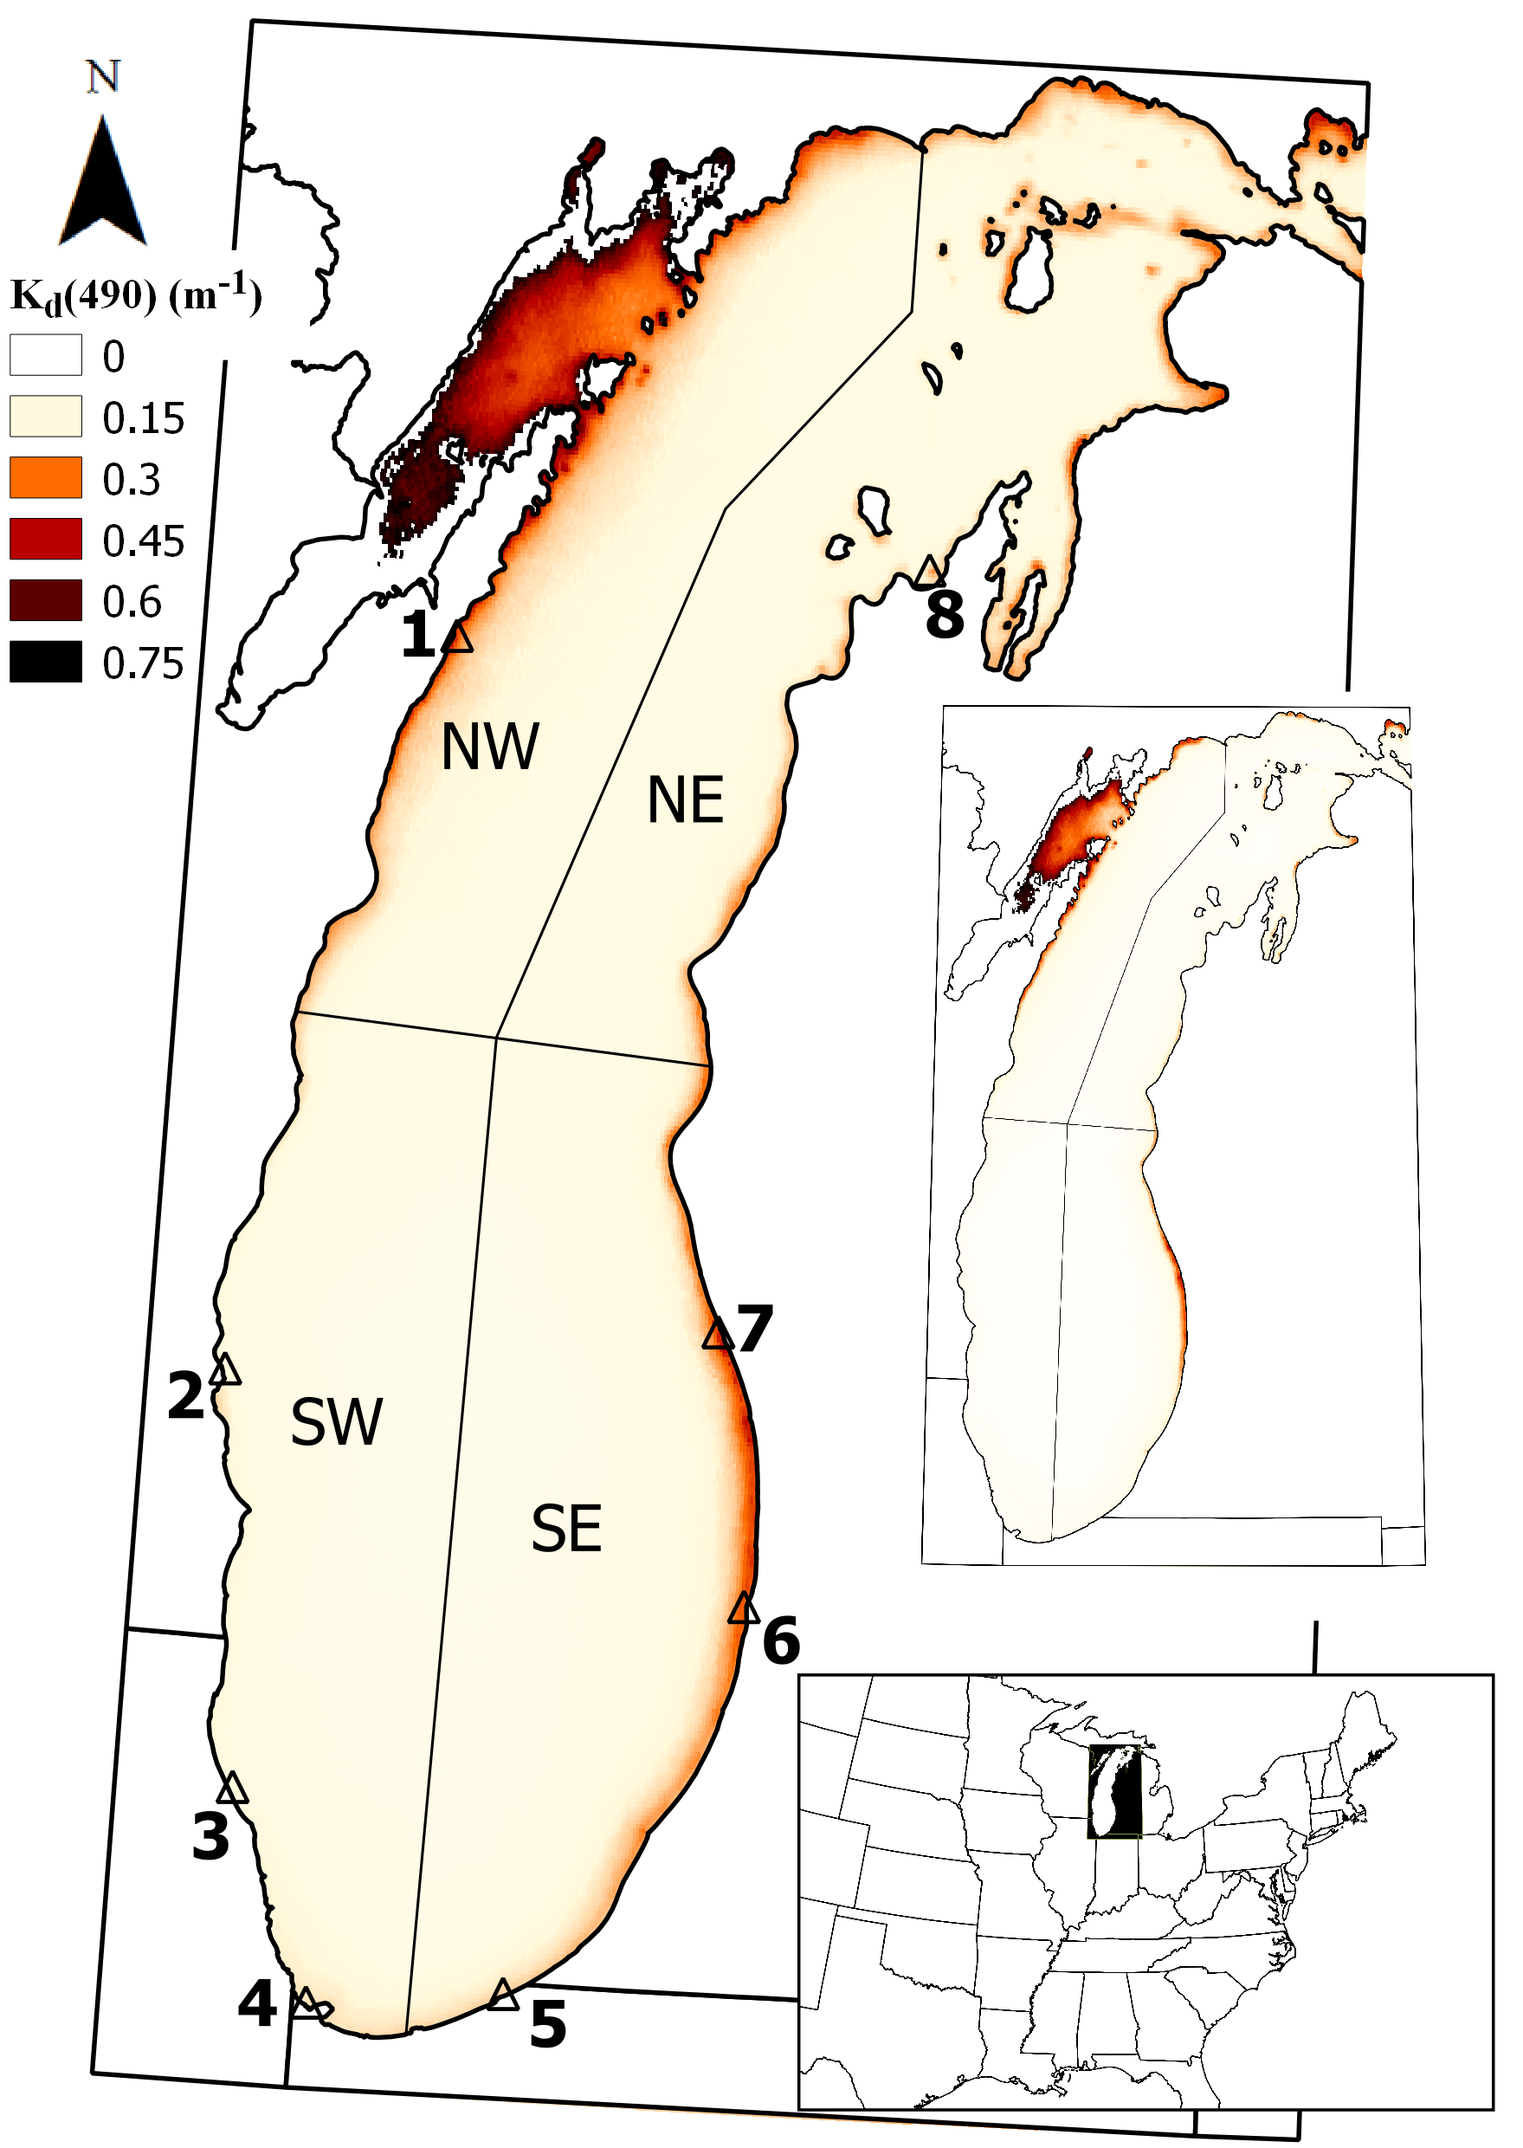
Figure 1

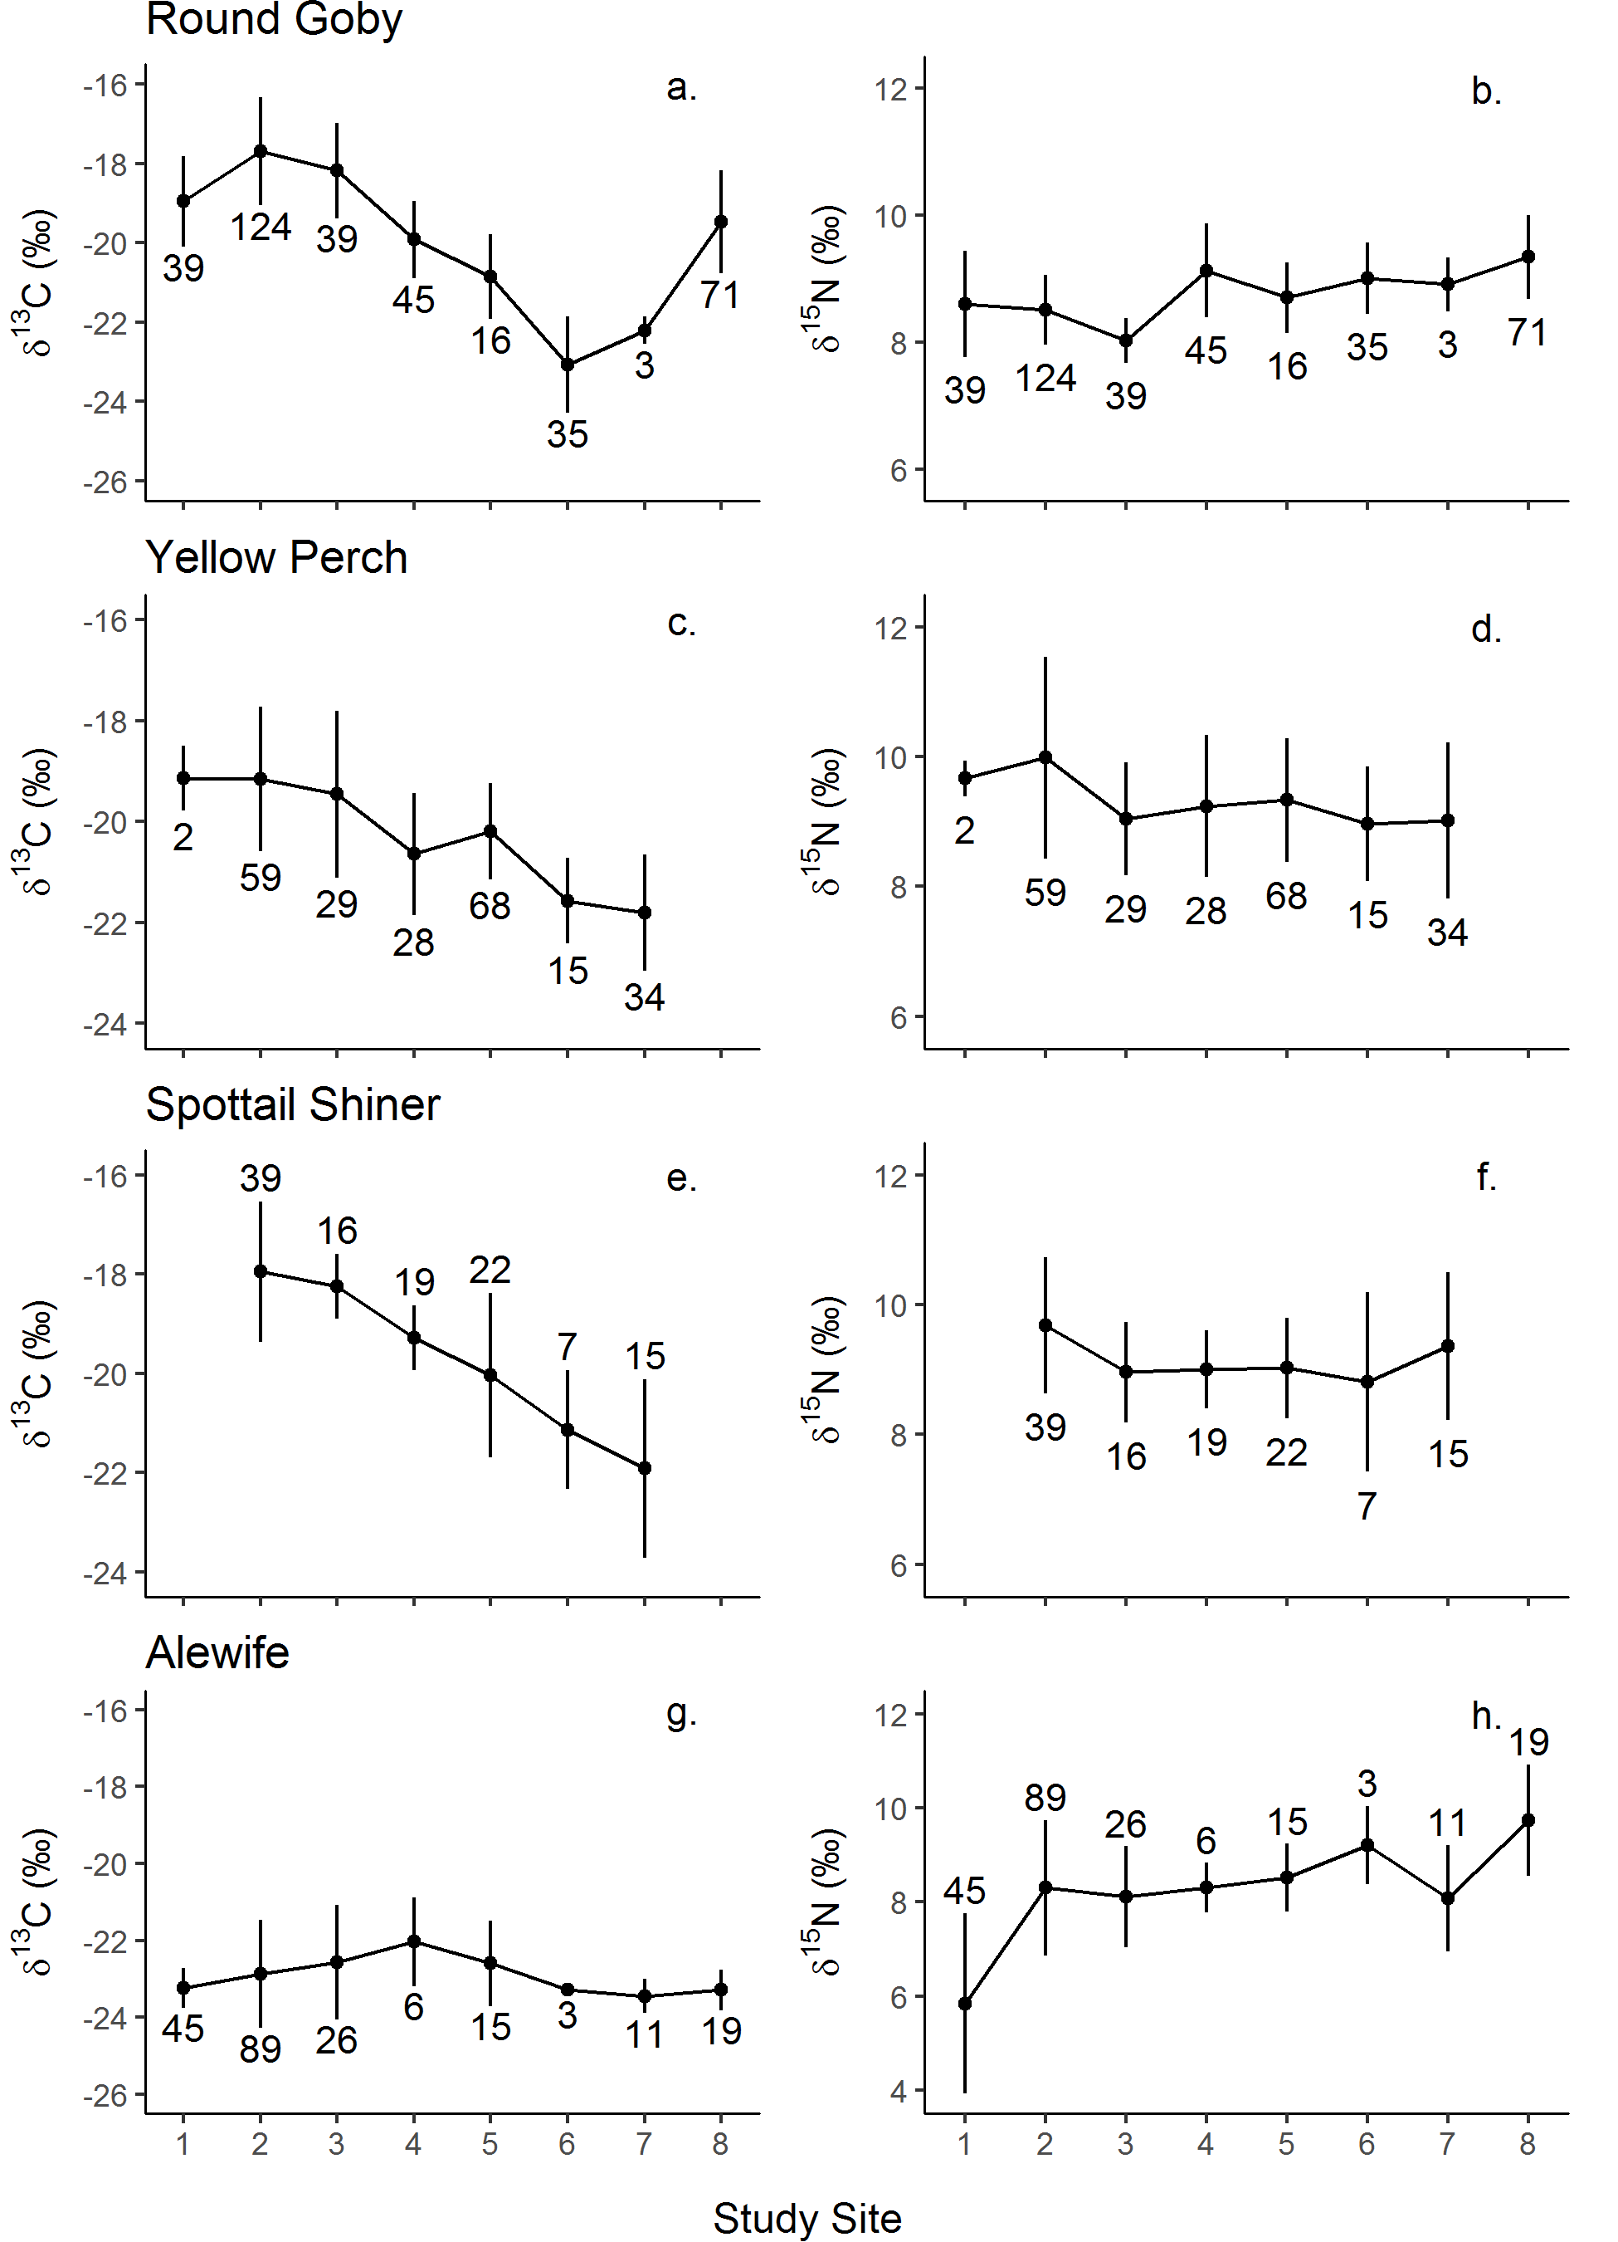
Figure 2

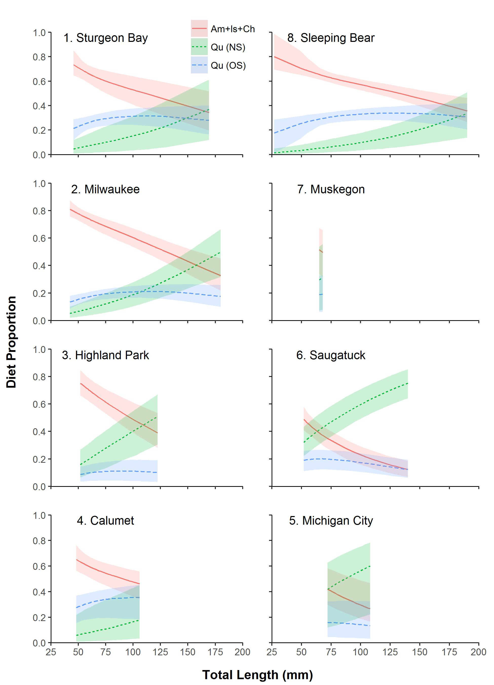
Figure 3

Figure 4
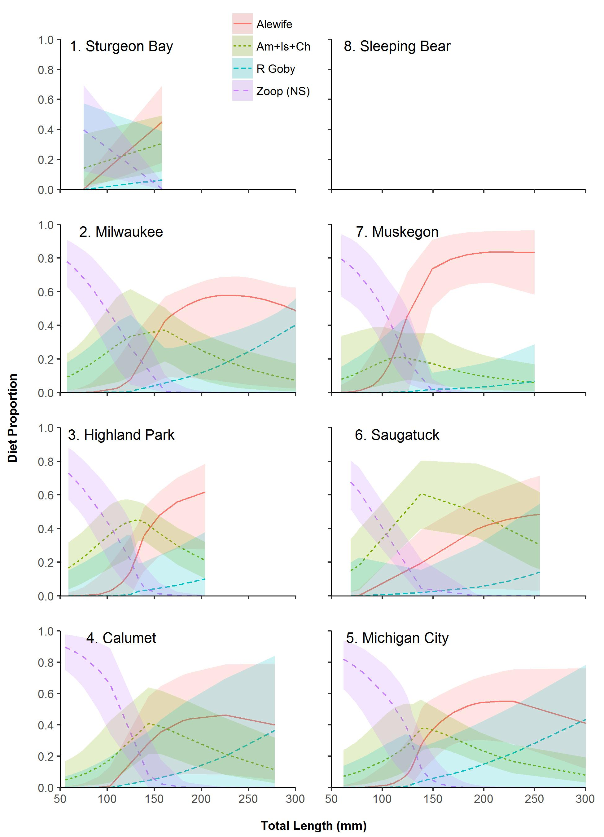

Figure 5
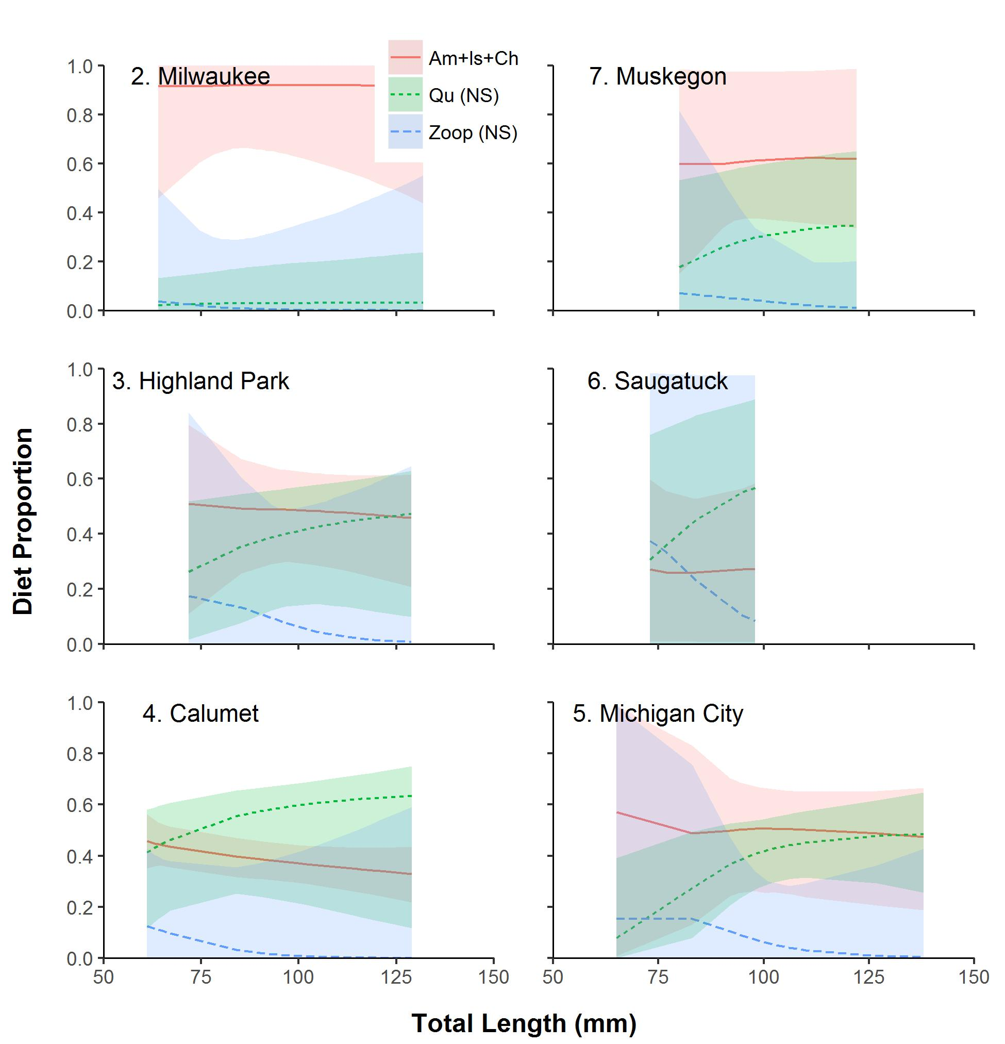

Figure 6
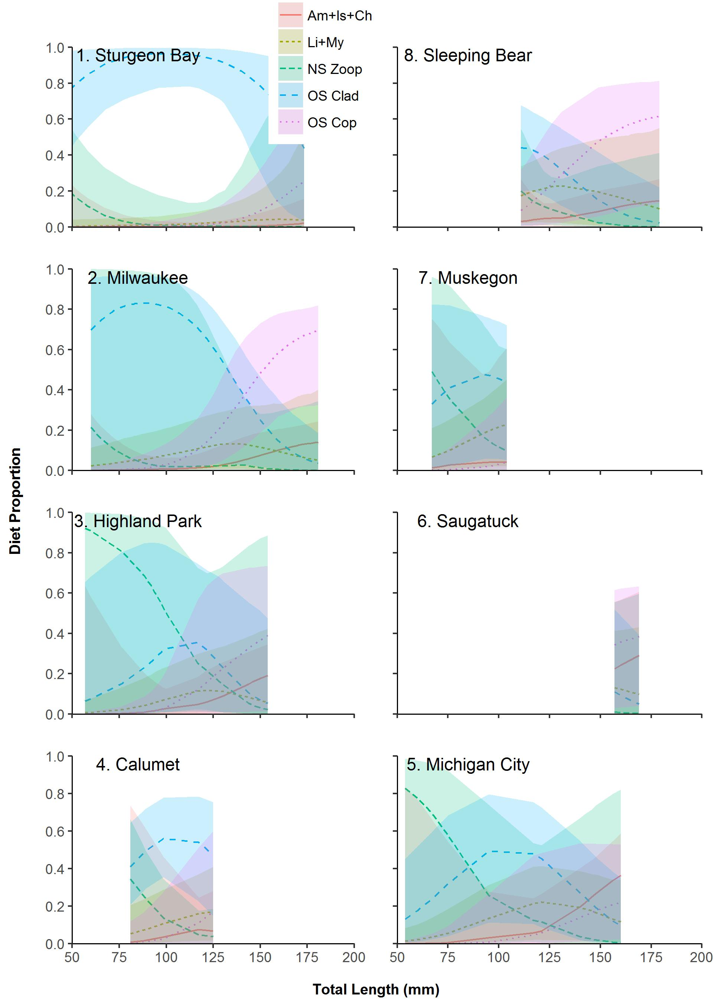

Figure 7
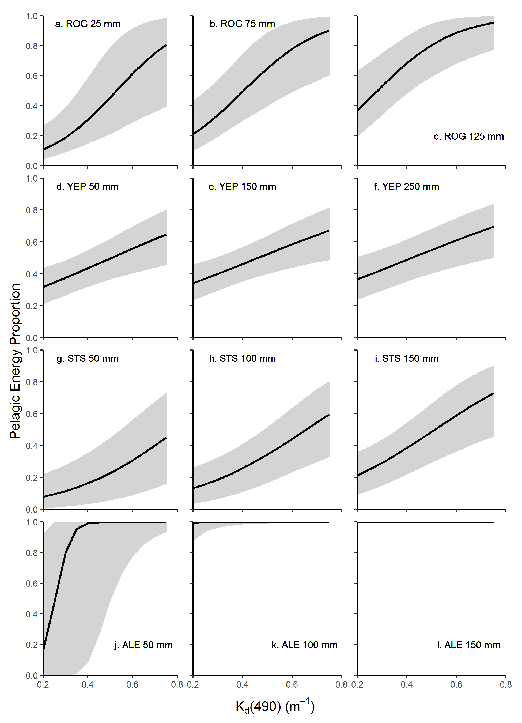

Appendix A

Turschak, B.A., S. Czesny, J. C. Doll, B. K. Grunert, T. O. Höök, J. Janssen, and H. A. Bootsma. 2017. Spatial Variation in Trophic Structure of Nearshore Fishes in Lake Michigan as it Relates to Water Clarity.- Can. J. Fish. Aquat. Sci. 000: 000-000

Fig. A1
Statistical range (2.5% and 97.5% quantiles, shaded gray) and median (black line) of NOMAD R_{rs} spectra relative to Lake Michigan R_{rs} spectra (red dashed lines) available on SeaBASS.

Fig. A1

